January 28, 2016

On Friday, February 5th, we will celebrate our 100th Day of School. In first grade, we celebrate this milestone with some special activities that help the children learn the value of 100. It is difficult to conceptualize such a large number at 6 or 7 years of age, so we have a lot of fun defining 100 in concrete ways.

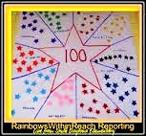
Each child is invited to create a poster of 100 items separated into groups of 10 to reinforce place value and the base 10-system. See picture for example. This at-home project will take the place of math homework for the week.

Since every memorable celebration includes food, we will be enjoying 100 snacks! With your donations, we will make our very own blend of 100th Day Trail Mix. We are asking each student to contribute a baggie full of 100 items. When combined, we will have a variety of treats to share as a class. For example, your child could bring 100 Goldfish crackers, 100 M&Ms, 100 chocolate chips, 100 Red Hots, 100 Teddy Grahams, etc. Please do NOT send any peanuts, tree nuts, or candy containing peanut butter, as some members of our class are allergic to these foods!

We are looking forward to this annual event next Friday! Thank you for your support in making this a special time for the children.
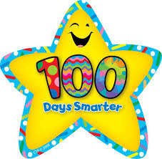
Mrs. Moll and Mrs. Miller

